实现技术：
JSSE（Java Security Socket Extension）
是Sun为了解决在Internet上的实现安全信息传输的解决方案。它实现了SSL和TSL（传输层安全）协议。在JSSE中包含了数据加密，服务器验证，消息完整性和客户端验证等技术。通过使用JSSE，可以在Client和Server之间通过TCP/IP协议安全地传输数据。
为了实现消息认证。
Server需要：
1）KeyStore: 其中保存服务端的私钥
2）Trust KeyStore:其中保存客户端的授权证书
Client需要：
1）KeyStore：其中保存客户端的私钥
2）Trust KeyStore：其中保存服务端的授权证书
使用Java自带的keytool命令，去生成这样信息文件：
1）生成服务端私钥，并且导入到服务端KeyStore文件中
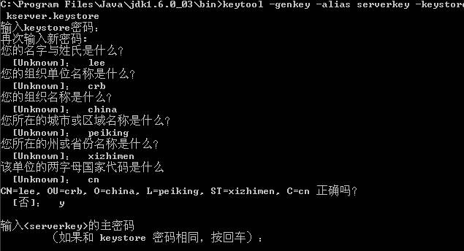
2）根据私钥，导出服务端证书
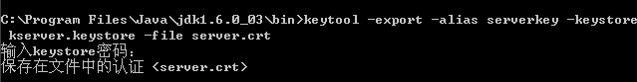

3）将服务端证书，导入到客户端的Trust KeyStore中
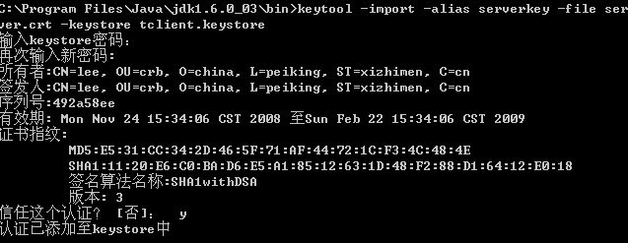

采用同样的方法，生成客户端的私钥，客户端的证书，并且导入到服务端的Trust KeyStore中
1）keytool -genkey -alias clientkey -keystore kclient.keystore
2）keytool -export -alias clientkey -keystore kclient.keystore -file client.crt
3）keytool -import -alias clientkey -file client.crt -keystore tserver.keystore
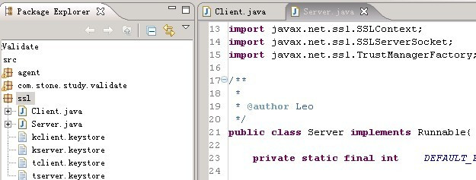

Server:
package ssl;
import java.io.BufferedInputStream;
import java.io.BufferedOutputStream;
import java.io.FileInputStream;
import java.io.InputStream;
import java.io.OutputStream;
import java.net.Socket;
import java.security.KeyStore;
import javax.net.ssl.KeyManagerFactory;
import javax.net.ssl.SSLContext;
import javax.net.ssl.SSLServerSocket;
import javax.net.ssl.TrustManagerFactory;

public class Server implements Runnable{
private static final int DEFAULT_PORT = 7777;
private static final String SERVER_KEY_STORE_PASSWORD = "123456";
private static final String SERVER_TRUST_KEY_STORE_PASSWORD = "123456";
private SSLServerSocket serverSocket;
/**
* 启动程序
*/
public static void main(String[] args) {
Server server = new Server();
server.init();
Thread thread = new Thread(server);
thread.start();
}
public synchronized void start() {
if (serverSocket == null) {
System.out.println("ERROR");
return;
}
while (true) {
try {
Socket s = serverSocket.accept();
InputStream input = s.getInputStream();
OutputStream output = s.getOutputStream();
BufferedInputStream bis = new BufferedInputStream(input);
BufferedOutputStream bos = new BufferedOutputStream(output);
byte[] buffer = new byte[20];
bis.read(buffer);
System.out.println("------receive:--------"+new String(buffer).toString());
bos.write("yes".getBytes());
bos.flush();
s.close();
} catch (Exception e) {
System.out.println(e);
}
}
}
public void init() {
try {
SSLContext ctx = SSLContext.getInstance("SSL");
KeyManagerFactory kmf = KeyManagerFactory.getInstance("SunX509");
TrustManagerFactory tmf = TrustManagerFactory.getInstance("SunX509");
KeyStore ks = KeyStore.getInstance("JKS");
KeyStore tks = KeyStore.getInstance("JKS");
ks.load(new FileInputStream("src/ssl/kserver.keystore"), SERVER_KEY_STORE_PASSWORD.toCharArray());
tks.load(new FileInputStream("src/ssl/tserver.keystore"), SERVER_TRUST_KEY_STORE_PASSWORD.toCharArray());
kmf.init(ks, SERVER_KEY_STORE_PASSWORD.toCharArray());
tmf.init(tks);
ctx.init(kmf.getKeyManagers(), tmf.getTrustManagers(), null);
serverSocket = (SSLServerSocket) ctx.getServerSocketFactory().createServerSocket(DEFAULT_PORT);
serverSocket.setNeedClientAuth(true);
} catch (Exception e) {
System.out.println(e);
}
}
public void run() {
// TODO Auto-generated method stub
start();
}
}
Client：
package ssl;
import java.io.BufferedInputStream;
import java.io.BufferedOutputStream;
import java.io.FileInputStream;
import java.io.IOException;
import java.io.InputStream;
import java.io.OutputStream;
import java.security.KeyStore;
import javax.net.ssl.KeyManagerFactory;
import javax.net.ssl.SSLContext;
import javax.net.ssl.SSLSocket;
import javax.net.ssl.TrustManagerFactory;
/**
* SSL Client
*/
public class Client {
private static final String DEFAULT_HOST = "127.0.0.1";
private static final int DEFAULT_PORT = 7777;
private static final String CLIENT_KEY_STORE_PASSWORD = "123456";
private static final String CLIENT_TRUST_KEY_STORE_PASSWORD = "123456";
private SSLSocket sslSocket;
/**
* 启动客户端程序
*/
public static void main(String[] args) {
Client client = new Client();
client.init();
client.process();
}
public void process() {
if (sslSocket == null) {
System.out.println("ERROR");
return;
}
try {
InputStream input = sslSocket.getInputStream();
OutputStream output = sslSocket.getOutputStream();
BufferedInputStream bis = new BufferedInputStream(input);
BufferedOutputStream bos = new BufferedOutputStream(output);
bos.write("1234567890".getBytes());
bos.flush();
byte[] buffer = new byte[20];
bis.read(buffer);
System.out.println(new String(buffer));
sslSocket.close();
} catch (IOException e) {
System.out.println(e);
}
}
public void init() {
try {
SSLContext ctx = SSLContext.getInstance("SSL");
KeyManagerFactory kmf = KeyManagerFactory.getInstance("SunX509");
TrustManagerFactory tmf = TrustManagerFactory.getInstance("SunX509");
KeyStore ks = KeyStore.getInstance("JKS");
KeyStore tks = KeyStore.getInstance("JKS");
ks.load(new FileInputStream("src/ssl/kclient.keystore"), CLIENT_KEY_STORE_PASSWORD.toCharArray());
tks.load(new FileInputStream("src/ssl/tclient.keystore"), CLIENT_TRUST_KEY_STORE_PASSWORD.toCharArray());
kmf.init(ks, CLIENT_KEY_STORE_PASSWORD.toCharArray());
tmf.init(tks);
ctx.init(kmf.getKeyManagers(), tmf.getTrustManagers(), null);
sslSocket = (SSLSocket) ctx.getSocketFactory().createSocket(DEFAULT_HOST, DEFAULT_PORT);
} catch (Exception e) {
System.out.println(e);
}
}
}

启动Server
启动Client，发送信息。
Server接收如下：正确解密
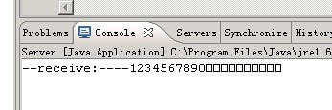

返回Client信息，如下：

如此，就完成了服务端和客户端之间的基于身份认证的交互。
client采用kclient.keystore中的clientkey私钥进行数据加密，发送给server。
server采用tserver.keystore中的client.crt证书（包含了clientkey的公钥）对数据解密，如果解密成功，证明消息来自client，进行逻辑处理。
server采用kserver.keystore中的serverkey私钥进行数据加密，发送给client。
client采用tclient.keystore中的server.crt证书（包含了serverkey的公钥）对数据解密，如果解密成功，证明消息来自server，进行逻辑处理。
如果过程中，解密失败，那么证明消息来源错误。不进行逻辑处理。这样就完成了双向的身份认证。

